

**DEPARTMENT OF ARTIFICIAL INTELLIGENCE AND DATA SCIENCE LAB MANUAL**

**AD23431 - STATISTICAL ANALYSIS AND COMPUTING**

**(REGULATION 2023)**

**RAJALAKSHMI ENGINEERING COLLEGE**

**Thandalam, Chennai-602015**

Name: Jishanthi R

Register No: 231801072

Year / Branch / Section: 2nd / AI&DS / FA

Semester: IV

Academic Year: 2024 - 2025

INDEX

| S.No. | Date | Title | Page No |
| --- | --- | --- | --- |
| 1. | 05/2/25 | Implement Simple Programs in R | 3 |
| 2. | 19/2/25 | Perform Data Preprocessing in R | 9 |
| 3. | 05/3/25 | Perform Statistical Analysis for a Given Dataset | 12 |
| 4. | 26/3/25 | Implement Decision Tree Algorithm in R | 17 |
| 5. | 02/4/25 | Implement K-Nearest Neighbor Algorithm in R | 21 |
| 6. | 16/4/25 | Implement Naive Bayesian Classifier in R | 26 |
| 7. | 16/4/25 | Implement Linear Regression in R | 30 |
| 8. | 23/4/25 | Implement K-means Clustering Algorithm in R | 33 |





**Aim:**

To Implement Simple Programs using R.

**Algorithm:**

**1. Basic Arithmetic Operations**

**a. Finding Area of Circle**

* Input: Read radius r.
* Process: Calculate the area using the formula:  
  Area=π×r2\text{Area} = \pi \times r^2Area=π×r2
* Output: Print the calculated area.

**2. Control Structures (if-else, for loop)**

**a. Check Whether the Given Year is Leap or Not**

* Input: Read a year ly.
* Process:
  + If ly is divisible by 400, it’s a leap year.
  + Else, if divisible by 100 (but not by 400), it’s not a leap year.
  + Else, if divisible by 4, it’s a leap year.
  + Otherwise, it’s not a leap year.
* Output: Print whether the year is a leap year or not.

**b. Reverse a Given Number**

* Input: Read a number num.
* Process:
  + Initialize rev = 0.
  + While num > 0:
    - Extract last digit: ld = num % 10.
    - Update rev = rev * 10 + ld.
    - Remove last digit: num = num // 10.
* Output: Print the reversed number.

**c. Finding Prime Numbers for the Given Range**

* Input: Read the number n (upper limit).
* Process:
  + For each number i from 1 to n, check if it's prime:
    - If divisible by any number from 2 to √i, it’s not prime.
    - If no divisors found, it is prime.
* Output: Print all prime numbers from 1 to n.

**3. Functions and Recursive Functions**

**a. Print the Fibonacci Sequence using Functions (Iterative)**

* Input: Read n (number of terms in the sequence).
* Process:
  + Initialize first two terms: a = 0, b = 1.
  + Print a and b.
  + Loop (n-2) times:
    - Calculate next term c = a + b.
    - Update a = b, b = c.
  + Print the sequence of n terms.

**b. Print the Fibonacci Sequence using Recursive Functions**

* Input: Read n (number of terms in the sequence).
* Process:
  + Define a recursive function fibo(n):
    - If n == 0, return 0 (base case).
    - If n == 1, return 1 (base case).
    - Else, return fibo(n-1) + fibo(n-2).
  + Call fibo(i) for each i from 0 to n-1 and print the sequence.

**Programs:**

**1. Basic Arithmetic Operations**

**a. Finding Area of Circle**

r=as.integer(readline(("Enter the radius: ")))

area=pi*r*r

print(area)

**Output:**

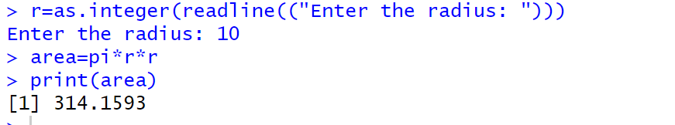

**2. Control Structure (if-else, for loop)**

**a. To Check Whether the Given Year is Leap or Not**

ly=as.integer(readline(("Enter a Number: ")))

if(ly%%400==0){

print("Leap Year")

}else if(ly%%100==0){

print("Not a Leap Year")

}else if(ly%%4==0){

print("Leap Year")

}else{

print("Not a Leap Year")

}

**Output:**

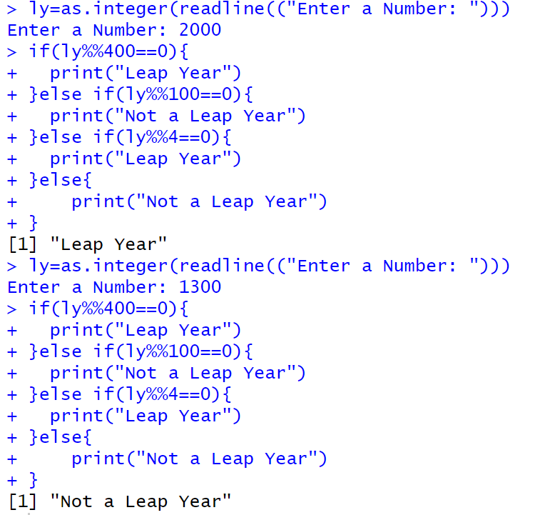

**b. Reverse a Given Number**

num=as.integer(readline("Enter a number: "))

rev=0

while(num>0){

ld=num%%10

rev=rev*10+ld

num=num%/%10

}

cat("Reversed NUmber",rev)

**Output:**

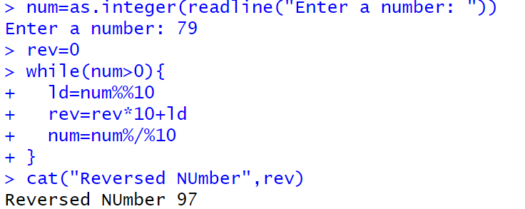

**c. Finding Prime Numbers for the Given Range**

prime<-function(n){

if(n<=1){

return (FALSE)}

for (i in 2:sqrt(n)){

if(n%%i==0){

return (FALSE)

}

}

return (TRUE)

}

n=as.integer(readline("Enter a number: "))

for (i in 1:n){

if(prime(i)){

print(i)

}

}

**Output:**

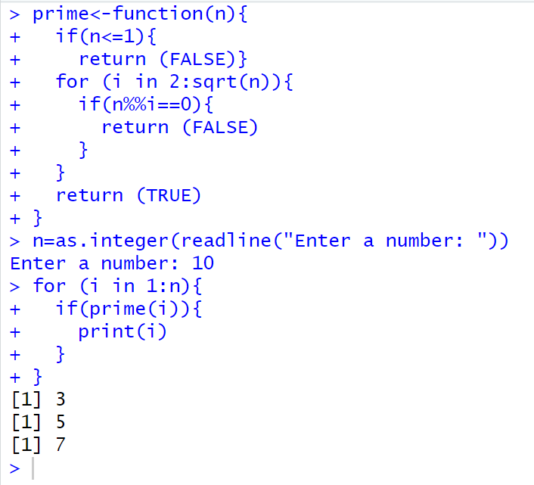

**3. Functions and Recursive Functions**

**a. Print the Fibonacci Sequence using Functions**

fibonacci_iterative <- function(n) {

fib_series <- numeric(n)

fib_series[1] <- 0

if (n > 1) fib_series[2] <- 1

for (i in 3:n) {

fib_series[i] <- fib_series[i-1] + fib_series[i-2]

}

return(fib_series)

}

n <- as.integer(readline("How many terms? "))

print(fibonacci_iterative(n))

**Output:**

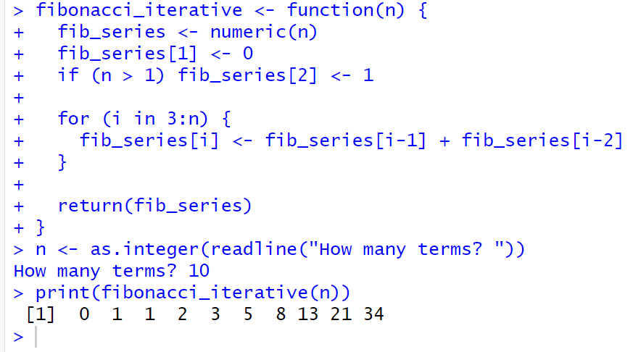

**b. Print the Fibonacci Sequence using Recursive Functions**

fibonacci_recursive <- function(n) {

if (n == 1) {

return(0)

} else if (n == 2) {

return(1)

} else {

return(fibonacci_recursive(n-1) + fibonacci_recursive(n-2))

}

}

n <- as.integer(readline("How many terms? "))

fib_series <- sapply(1:n, fibonacci_recursive)

print(fib_series)

**Output:**

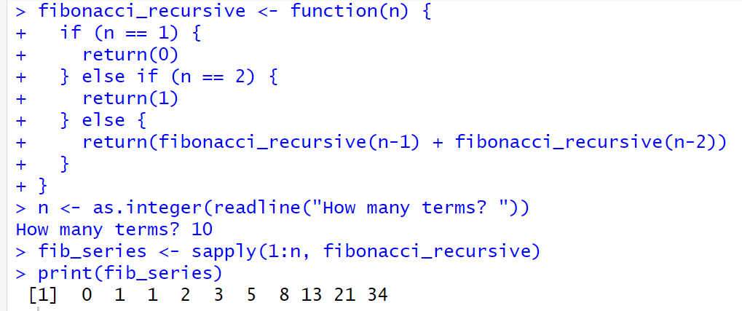

**Result:**

The Simple Program using R is Successfully Implemented.



**Aim:**

To Perform Preprocessing of data using R.

**Algorithm:**

1. **Loading Data / Cleaning the Data:**
   * Create emp_df2 with columns: emp_id, age, dept, salary, experience.
2. **Storing / Uploading Data to Excel Sheet:**
   * Create a workbook wb, add a worksheet "Employee Data Preprocessing", and save emp_df2 to emp_df2.xlsx.
3. **Cleaning the Data:**
   * Replace missing age and salary with their respective mean values.
   * Convert dept to numeric.
4. **Scaling the Data:**
   * Scale the age, salary, and experience columns using z-score and update emp_df2.
5. **Splitting the Data into Train and Test:**
   * Set seed, split data into 80% train and 20% test (dataTrain, dataTest).
6. **Correlation Matrix**:
   * Compute the correlation matrix for the scaled features (age, salary, experience) to examine relationships between them.

**Programs:**

library(openxlsx)

emp_df2<-data.frame(

emp_id=1:10,

age=c(25,30,35,NA,55,65,NA,25,85,78),

dept=c("AI&DS","IT","AI&ML","CSE","PHY","FT","BIOTECH","CSBS","CIVIL","MECH"),

salary=c(50000,85100,52802,144510,552410,520000,445100,5552410,524160,NA),

experience=c(2,5,8,14,4,6,3,2,4,5)

)

wb<-createWorkbook()

addWorksheet(wb,"Employee Data Preprocessing")

writeData(wb,"Employee Data Preprocessing",emp_df2)

saveWorkbook(wb,"C:\\Users\\karthick.S\\OneDrive\\Documents\\231801079-4\\SAC\\emp_df2.xlsx",overwrite = TRUE)

emp_df2$age[is.na(emp_df2$age)]<-floor(mean(emp_df2$age,na.rm = TRUE))

emp_df2$salary[is.na(emp_df2$salary)]<-floor(mean(emp_df2$salary,na.rm = TRUE))

emp_df2$dept<-as.numeric(as.factor(emp_df2$dept))

emp_df_scaled<-scale(emp_df2[,c("age","salary","experience")])

emp_df2<-data.frame(emp_df2[,c("emp_id","dept")],emp_df_scaled)

correlation_matrix <- cor(emp_df2[, c("age", "salary", "experience")])

print("Correlation Matrix:")

print(correlation_matrix)

set.seed(42)

trainIndex<-sample(1:nrow(emp_df2),0.8*nrow(emp_df2))

dataTrain<-emp_df2[trainIndex,]

dataTest<-emp_df2[-trainIndex,]

print(dataTrain)

print(dataTest)

**Output:**

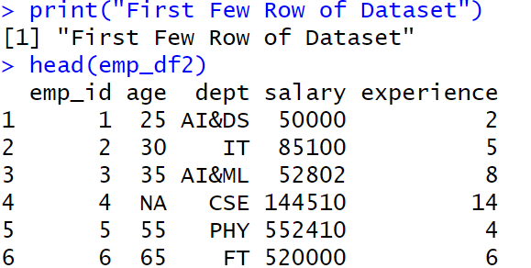

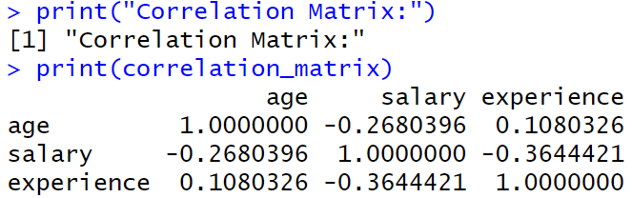

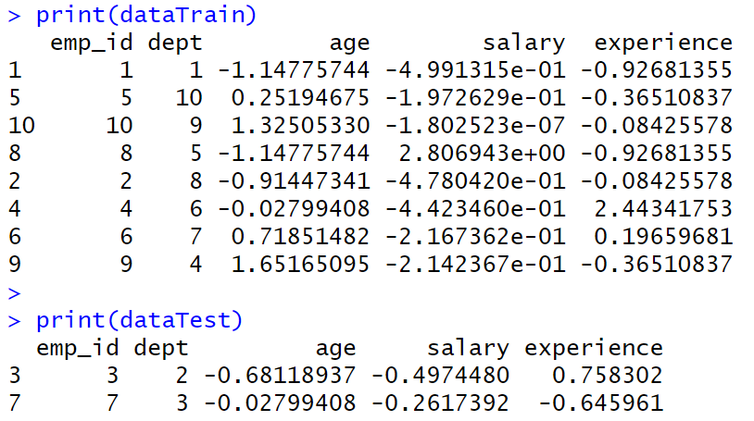

**Result:**

Thus, Preprocessing data is cleaned, transformed and formatted dataset ready for analysis or modelling.



**Aim:**

To Perform Statistical Analysis for Given Dataset.

**Algorithm:**

**1. Loading Libraries:**

* Load the necessary libraries: dplyr, summarytools, psych.

**2. Loading Data:**

* Create a dataset data with columns Age and Salary.

**3. Statistical Analysis:**

* Mean: Calculate the mean of Age.
* Median: Calculate the median of Age.
* Mode: Calculate the mode of Age using the table function.
* Variance: Calculate the variance of Age.
* Standard Deviation: Calculate the standard deviation of Age.
* Correlation: Calculate the correlation between Age and Salary.

**4. Descriptive Statistics:**

* Use the summary() function to generate summary statistics for the dataset.

**5. Quantile Analysis:**

* Calculate the quantiles for both Age and Salary.

**6. Interquartile Range (IQR):**

* Calculate the IQR for both Age and Salary.

**7. Hypothesis Testing (T-Test):**

* Perform a one-sample t-test on Salary with a hypothesized mean of 70,000.

**8. Visualization:**

* Boxplot: Create a boxplot for Age and Salary to visualize their distributions.

**9. Detailed Descriptive Statistics:**

* Use describe() from the psych package to get detailed statistics for Age and Salary.
* Use descr() from the summarytools package for detailed descriptive statistics.

**Program:**

library(dplyr)

library(summarytools)

library(psych)

data <- data.frame(Age = c(25, 30, 28, 35, 40, 45, 50, 32, 38, 42),

Salary = c(50000, 60000, 55000, 75000, 80000, 85000, 90000, 65000, 78000, 82000))

cat("Dataset:\n")

print(data)

mean_age <- mean(data$Age)

median_age <- median(data$Age)

mode_age <- as.numeric(names(sort(table(data$Age), decreasing = TRUE))[1])

var_age <- var(data$Age)

sd_age <- sd(data$Age)

corr <- cor(data$Age, data$Salary)

cat("\nStatistical Analysis Results:\n")

print(mean_age)

print(median_age)

print(mode_age)

print(var_age)

print(sd_age)

print(corr)

data_summary <- summary(data)

print(data_summary)

quantile_age <- quantile(data$Age)

quantile_salary <- quantile(data$Salary)

IQR_age <- IQR(data$Age)

IQR_salary <- IQR(data$Salary)

cat("Quantile Age", quantile_age)

cat("\nQuantile Salary", quantile_salary)

cat("\nIQR Age", IQR_age)

cat("\nIQR Salary", IQR_salary)

t_test_result <- t.test(data$Salary, mu = 70000)

print(t_test_result)

boxplot(data$Age, main = "Boxplot of Age", ylab = "Age", col = "lightblue")

boxplot(data$Salary, main = "Boxplot of Salary", ylab = "Salary", col = "lightgreen")

cat("\nDescribe Method From Describe of psych")

descr_stats <- describe(data[, c("Age", "Salary")])

print("Detailed Descriptive Statistics:")

print(descr_stats)

cat("\nDescribe Method From Descr of SummaryTools")

print(descr(data))

**Output:**

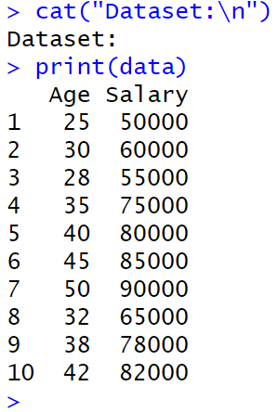

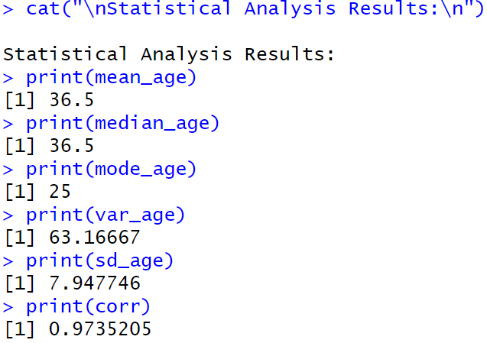

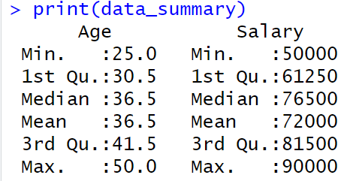

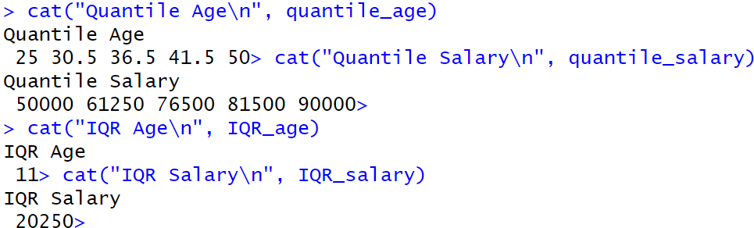

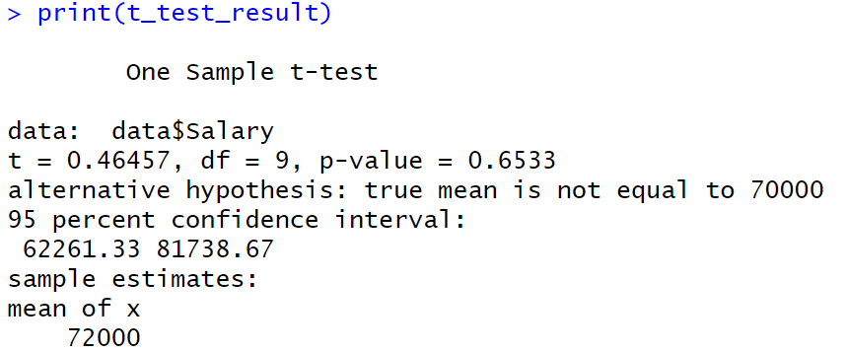

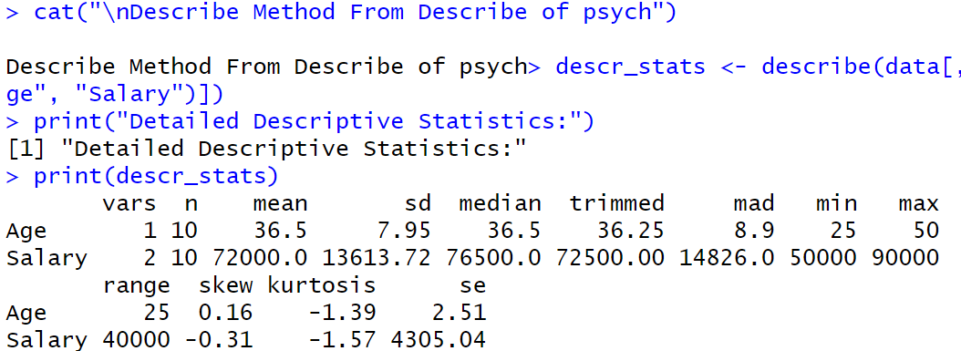

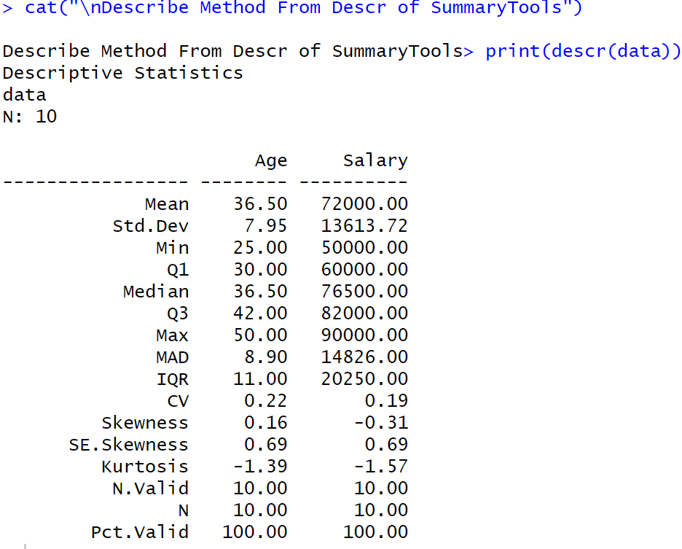

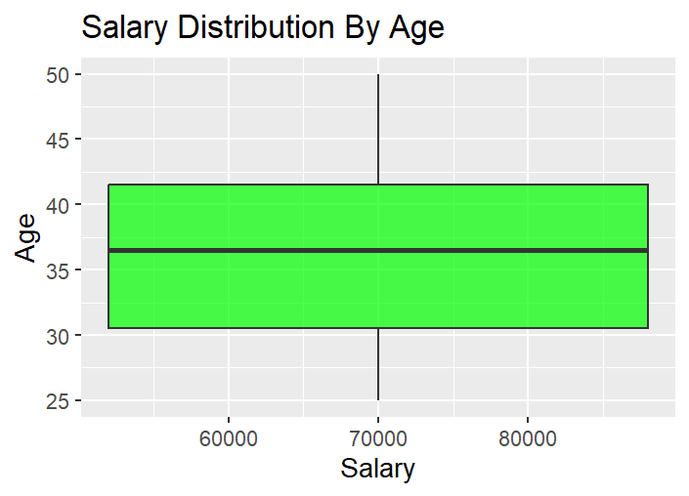

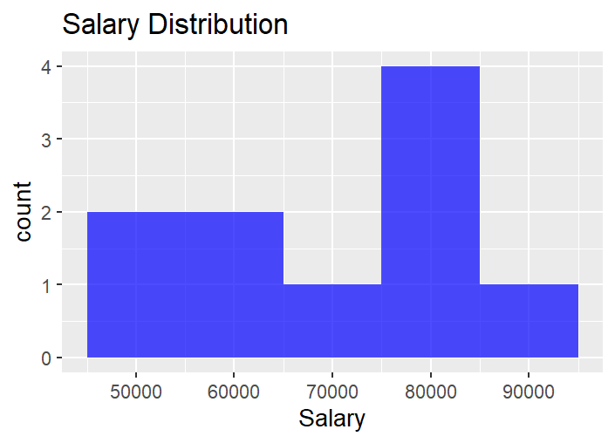

**Result:**

Thus, Statistical Analysis for a Given Dataset using is Analysed and Scaled.



**Aim:**

Implement a Decision Tree Classification on the Given Dataset.

**Procedure:**

**1. Load Required Libraries**

* Load the necessary libraries:
  + rpart for building decision tree models.
  + rpart.plot for visualizing decision trees.
  + caret for data splitting and model evaluation.

**Code:**

library(rpart)

library(rpart.plot)

library(caret)

**2. Load the Dataset**

* Load the Iris dataset (built-in in R).
* Display the first few rows to understand the data structure.

**Code:**

data("iris")

print("First Few Rows of Dataset")

head(iris)

**3. Split the Data into Training and Testing Sets**

* Set a seed for reproducibility.
* Use createDataPartition to split the data into:
  + 80% training set
  + 20% testing set

**Code:**

set.seed(123)

train_index <- createDataPartition(iris$Species, p = 0.8, list = FALSE)

train_data <- iris[train_index, ]

test_data <- iris[-train_index, ]

**4. Train a Decision Tree Model**

* Build a decision tree classifier using rpart, predicting Species based on the features.

**Code:**

tree_model <- rpart(Species ~ ., data = train_data, method = "class")

print(tree_model)

**5. Visualize the Decision Tree**

* Plot the trained decision tree using rpart.plot with enhanced formatting.

**Code:**

rpart.plot(tree_model,

main = "Decision Tree for Iris Dataset",

type = 3,

extra = 101,

under = TRUE,

tweak = 1.2,

box.palette = "RdBu")

**6. Make Predictions on Test Data**

* Use the trained model to predict the species on the test dataset.

**Code:**

pred <- predict(tree_model, test_data, type = "class")

**7. Evaluate Model Performance**

* Create a confusion matrix to compare predicted vs actual labels.
* Print evaluation metrics like accuracy, sensitivity, specificity, etc.

**Code:**

conf_mat <- confusionMatrix(pred, test_data$Species)

print(conf_mat)

**Output:**

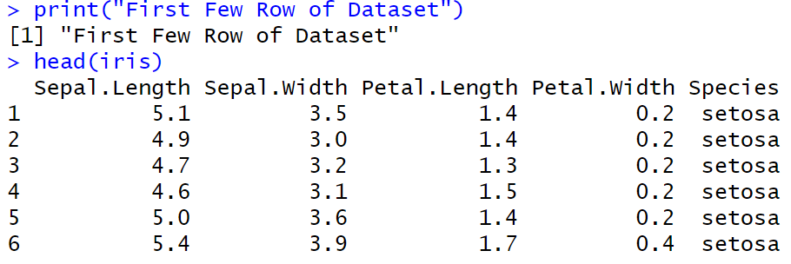

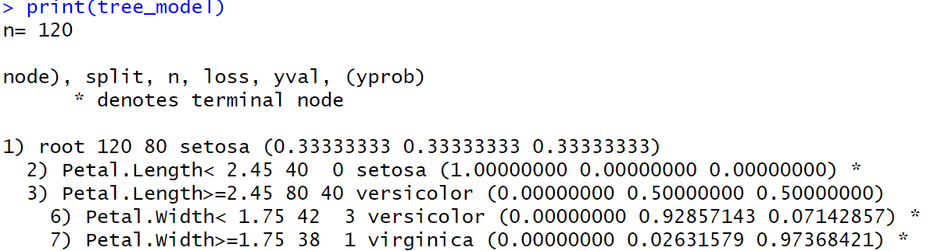

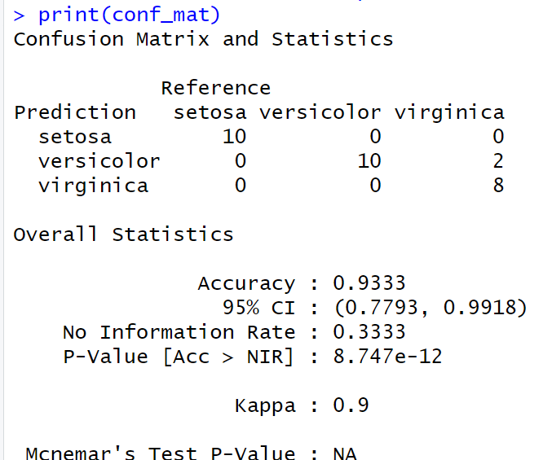

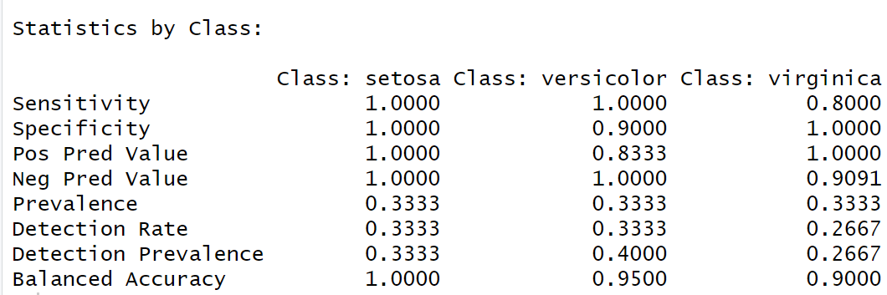

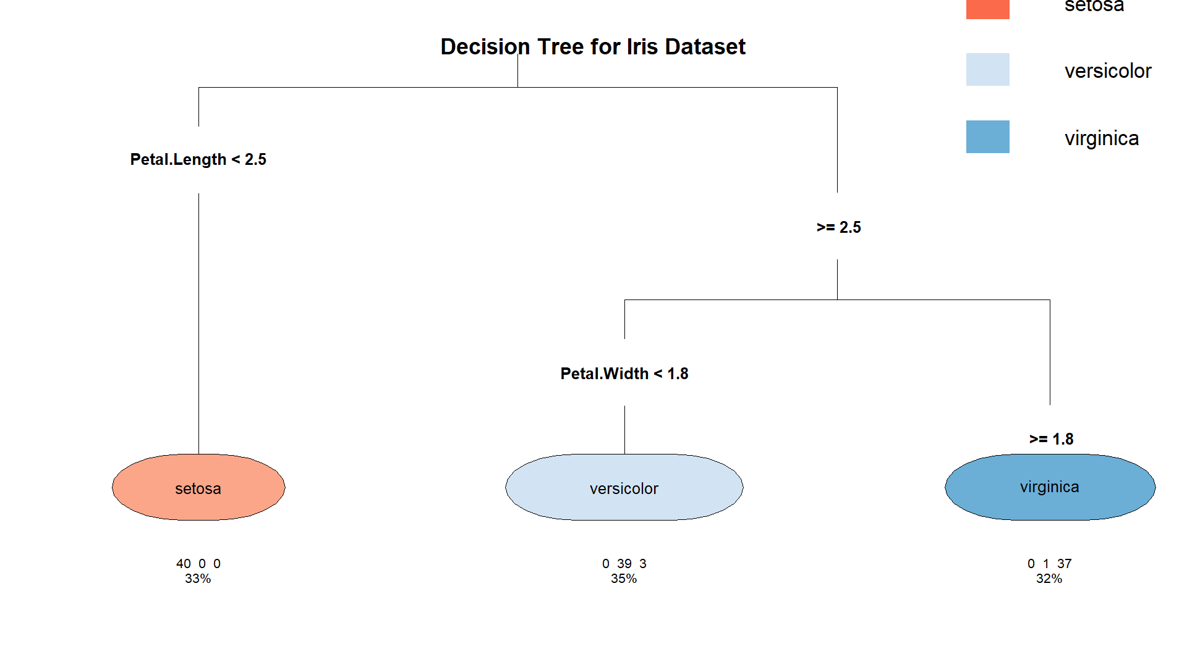

**Result:**

The Decision Tree is Implemented Successfully.



**Aim:**

Implement a KNN Classification on the Given Dataset.

**Procedure:**

**1. Load Required Libraries**

* Load the necessary libraries:
  + class for KNN model.
  + ggplot2 for plotting.
  + GGally for advanced plots (pairwise plots).
  + caret for data partitioning and evaluation.

**Code:**

library(class)

library(ggplot2)

library(GGally)

library(caret)

**2. Load the Dataset**

* Load the Iris dataset.
* Display the first few rows to understand the structure.

**Code:**

data("iris")

print("First Few Rows of Dataset")

head(iris)

**3. Define a Normalize Function**

* Create a custom function to normalize (scale between 0 and 1) the numerical feature columns.

**Code:**

normalize <- function(x) {

return((x - min(x)) / (max(x) - min(x)))

}

**4. Normalize the Feature Columns**

* Apply the normalization function to the first four feature columns.
* Add back the Species column separately.

**Code:**

iris_norm <- as.data.frame(lapply(iris[1:4], normalize))

iris_norm$Species <- iris$Species

**5. Split the Data into Training and Testing Sets**

* Set a random seed for reproducibility.
* Use createDataPartition to split:
  + 80% for training
  + 20% for testing

**Code:**

set.seed(123)

train_index <- createDataPartition(iris$Species, p = 0.8, list = FALSE)

train_data <- iris_norm[train_index, ]

test_data <- iris_norm[-train_index, ]

**6. Extract Training and Test Labels**

* Separate the labels (Species) from the feature data for both train and test sets.

**Code:**

train_labels <- train_data$Species

test_labels <- test_data$Species

**7. Train the KNN Model**

* Train the K-Nearest Neighbors model using:
  + Normalized feature columns
  + k = 5 neighbors.

**Code:**

knn_model <- knn(train = train_data[, 1:4], test = test_data[, 1:4], cl = train_labels, k = 5)

print(knn_model)

**8. Visualize the Data**

* Create visualizations to understand feature distributions:
  + Scatter plot of Sepal Length vs Sepal Width.
  + Pairwise plots (all feature combinations).

**Code:**

ggplot(data = iris, aes(x = Sepal.Length, y = Sepal.Width, color = Species)) +

geom_point() +

labs(title = "Scatter Plot of Sepal Dimensions", x = "Sepal Length", y = "Sepal Width") +

theme_minimal()

ggpairs(iris, aes(color = Species)) +

theme_minimal()

**9. Evaluate Model Performance**

* Generate a confusion matrix comparing predictions and true labels.
* Print classification results including accuracy, sensitivity, and specificity.

**Code:**

conf_mat <- confusionMatrix(knn_model, test_labels)

print(conf_mat)

**Output:**

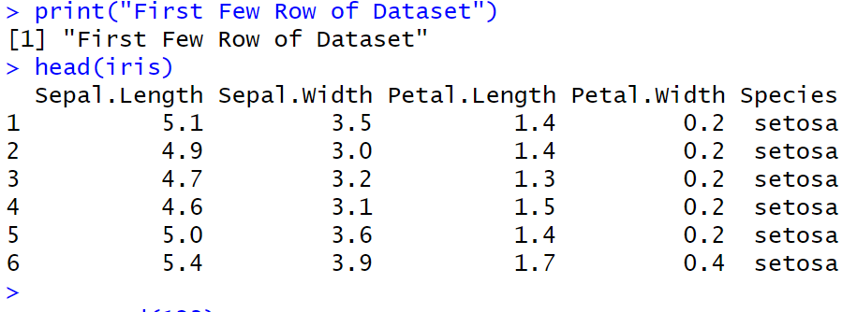

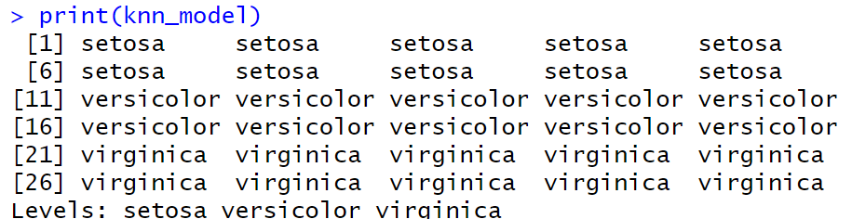

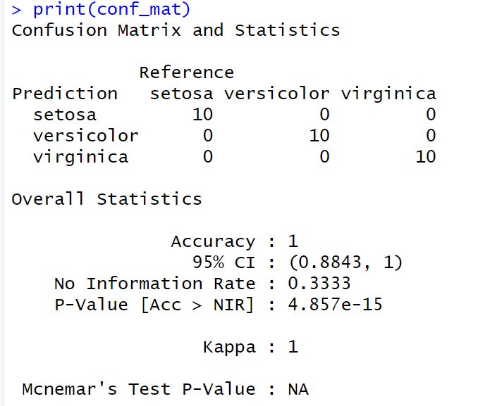

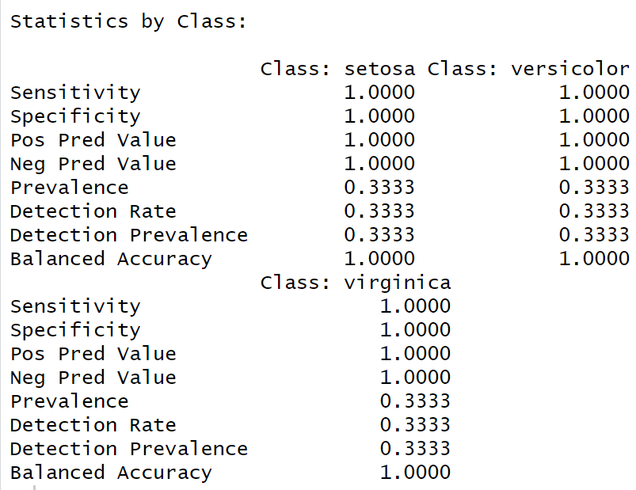

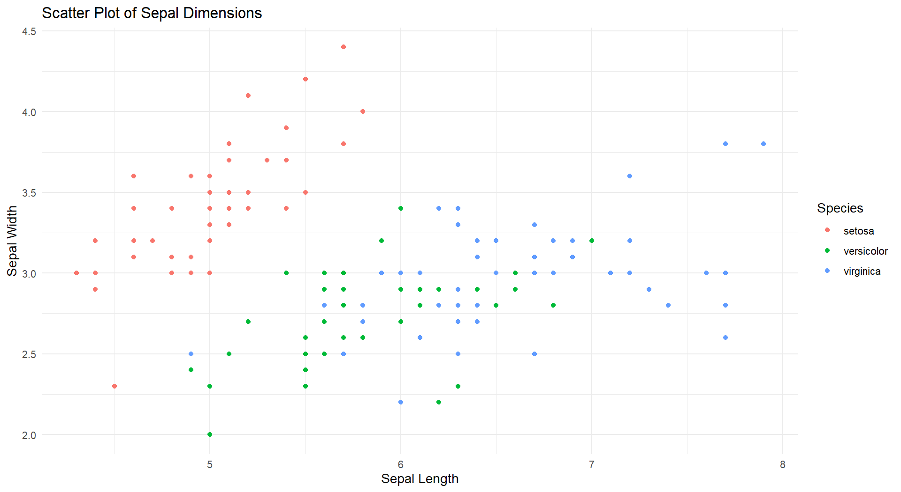

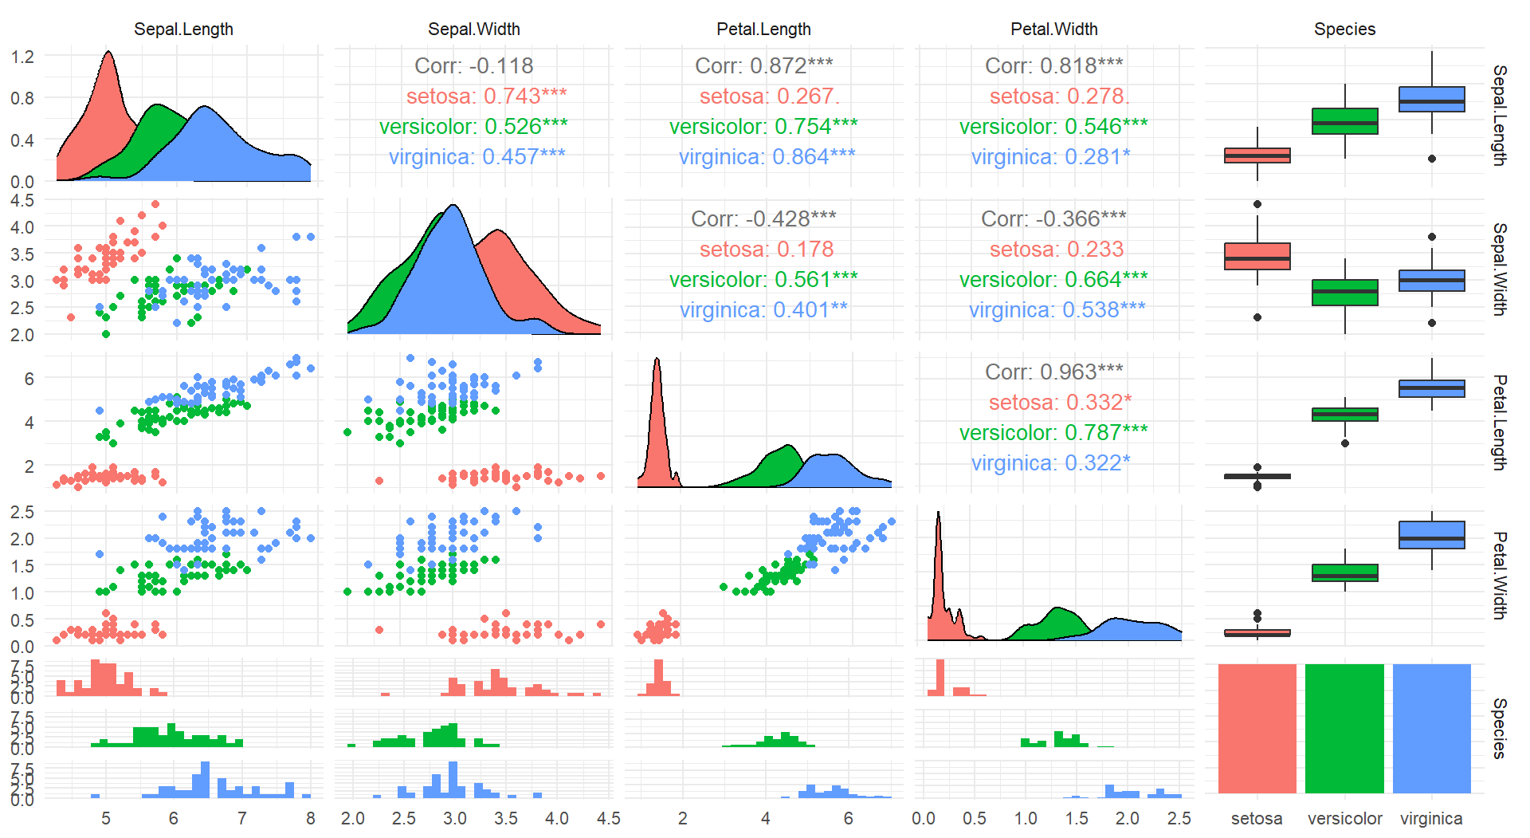

**Result:**

The KNN Classification is Successfully Implemented.



**Aim:**

Implement a Naïve Bayes Classification on the Given Dataset.

**Procedure:**

**1. Load Required Libraries**

* Load the necessary libraries:
  + e1071 for the Naive Bayes model.
  + ggplot2 for visualization.
  + caret for data partitioning and evaluation.

**Code:**

library(e1071)

library(ggplot2)

library(caret)

**2. Load the Dataset**

* Load the Iris dataset.
* Display the first few rows for a quick overview.

**Code:**

data("iris")

print("First Few Rows of Dataset")

head(iris)

**3. Split the Data into Training and Testing Sets**

* Set a random seed to ensure reproducibility.
* Split the data into:
  + 80% for training
  + 20% for testing

**Code:**

set.seed(123)

train_index <- createDataPartition(iris$Species, p = 0.8, list = FALSE)

train_data <- iris[train_index, ]

test_data <- iris[-train_index, ]

**4. Extract Training and Test Labels**

* Assign the Species column as the labels for training and testing.

**Code:**

train_labels <- train_data$Species

test_labels <- test_data$Species

**5. Train the Naive Bayes Model**

* Train the Naive Bayes classifier using the training data.

**Code:**

nb_model <- naiveBayes(Species ~ ., data = train_data)

print(nb_model)

**6. Visualize the Data**

* Create a scatter plot of Sepal Length vs Sepal Width colored by species.

**Code:**

ggplot(data = iris, aes(x = Sepal.Length, y = Sepal.Width, color = Species)) +

geom_point() +

labs(title = "Scatter Plot of Sepal Dimensions", x = "Sepal Length", y = "Sepal Width") +

theme_minimal()

**7. Make Predictions on the Test Data**

* Predict the species for the test dataset using the trained model.

**Code:**

pred <- predict(nb_model, test_data)

**8. Evaluate Model Performance**

* Generate a confusion matrix to compare the predicted labels and true labels.
* Print evaluation metrics like accuracy, sensitivity, and specificity.

**Code:**

conf_mat <- confusionMatrix(pred, test_labels)

print(conf_mat)

**Output:**

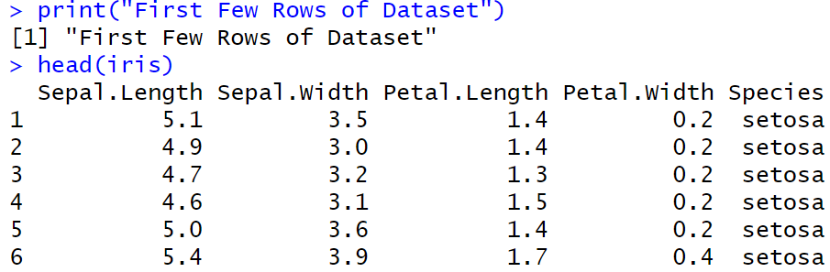

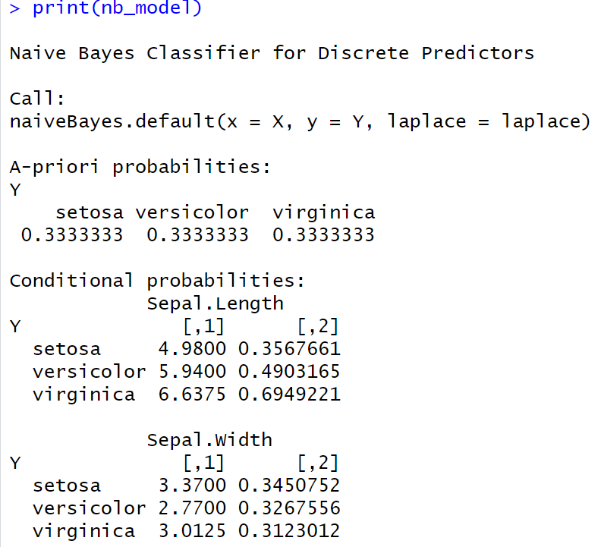

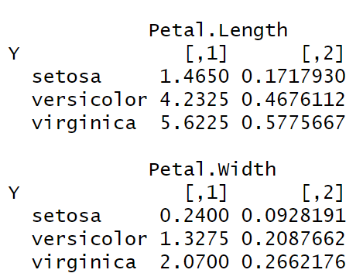

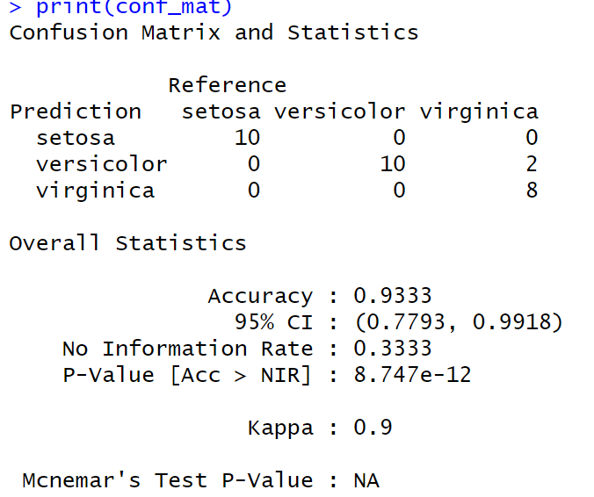

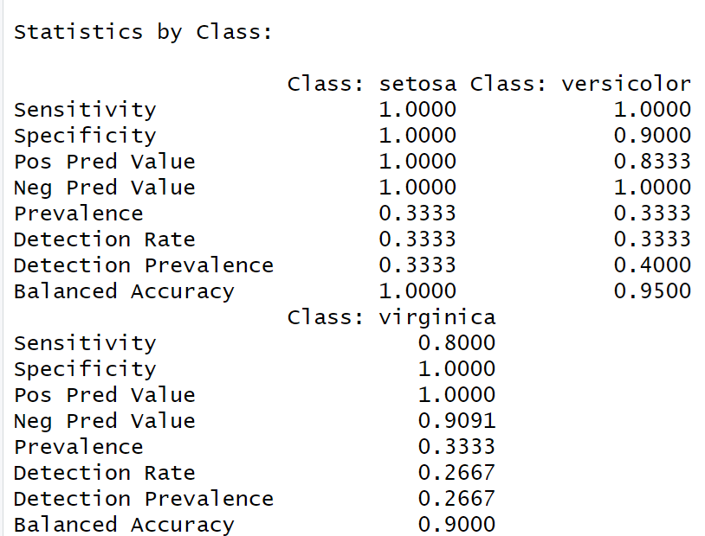

**Result:**

The Naive Bayes classification is successfully implemented.



The Naïve Bayes Classification is Successfully Implemented.

**Aim:**

Implement a Linear Regression on the Given Dataset.

**Procedure:**

**1. Load Required Libraries**

* Load the necessary libraries:
  + ggplot2 for visualization.
  + caret for splitting the data and evaluating the model.

**Code:**

library(ggplot2)

library(caret)

**2. Load the Dataset**

* Load the Headbrain dataset from a CSV file.
* Display the first few rows to inspect the data.

**Code:**

df <- read.csv("C:/Users/karthick.S/OneDrive/Documents/231801079-4/SAC/headbrain.csv")

print("First Few Rows of Dataset")

head(df)

**3. Split the Data into Training and Testing Sets**

* Set a random seed for reproducibility.
* Split the data into:
  + 70% for training
  + 30% for testing

**Code:**

set.seed(123)

index <- createDataPartition(df$Brain.Weight.grams., p = 0.7, list = FALSE)

train <- df[index, ]

test <- df[-index, ]

**4. Train the Linear Regression Model**

* Train a linear regression model to predict Brain.Weight.grams. based on Head.Size.cm.3..

**Code:**

print("Linear Regression Model")

model <- lm(Brain.Weight.grams. ~ Head.Size.cm.3., data = train)

print(model)

**5. Make Predictions on the Test Data**

* Use the trained model to predict brain weight values for the test dataset.

**Code:**

pred <- predict(model, newdata = test)

**6. Evaluate Model Performance**

* Use postResample to calculate evaluation metrics:
  + RMSE (Root Mean Squared Error)
  + R-squared (Coefficient of Determination)
  + MAE (Mean Absolute Error)

**Code:**

evaluation <- postResample(pred, test$Brain.Weight.grams.)

cat("RMSE:", evaluation["RMSE"], "\n")

cat("R-squared:", evaluation["Rsquared"], "\n")

cat("MAE:", evaluation["MAE"], "\n")

**7. Visualize the Data**

* Plot the scatter points of the original data.
* Overlay the regression line based on the model’s predictions.

**Code:**

x_vals <- seq(min(df$Head.Size.cm.3.) - 100, max(df$Head.Size.cm.3.) + 100, length.out = 1000)

pred_line <- data.frame(Head.Size.cm.3. = x_vals)

pred_line$Brain.Weight.grams. <- predict(model, newdata = pred_line)

plot(df$Head.Size.cm.3., df$Brain.Weight.grams.,

col = "green", pch = 19,

xlab = "Head Size (cm³)",

ylab = "Brain Weight (grams)",

main = "Head Size vs Brain Weight with Regression Line")

lines(pred_line$Head.Size.cm.3., pred_line$Brain.Weight.grams., col = "red", lwd = 2)

**Output:**

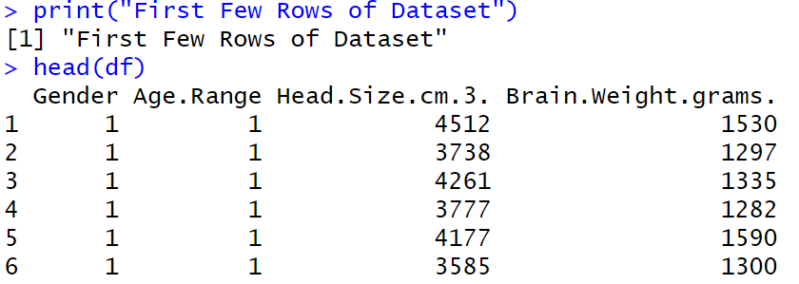

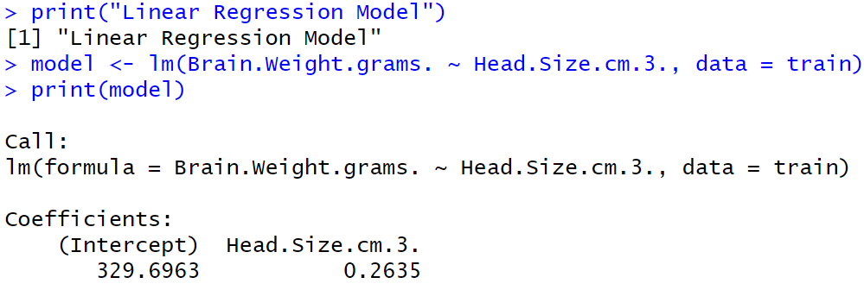

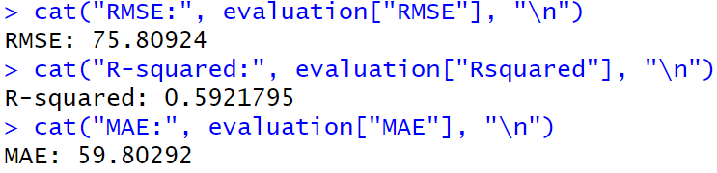

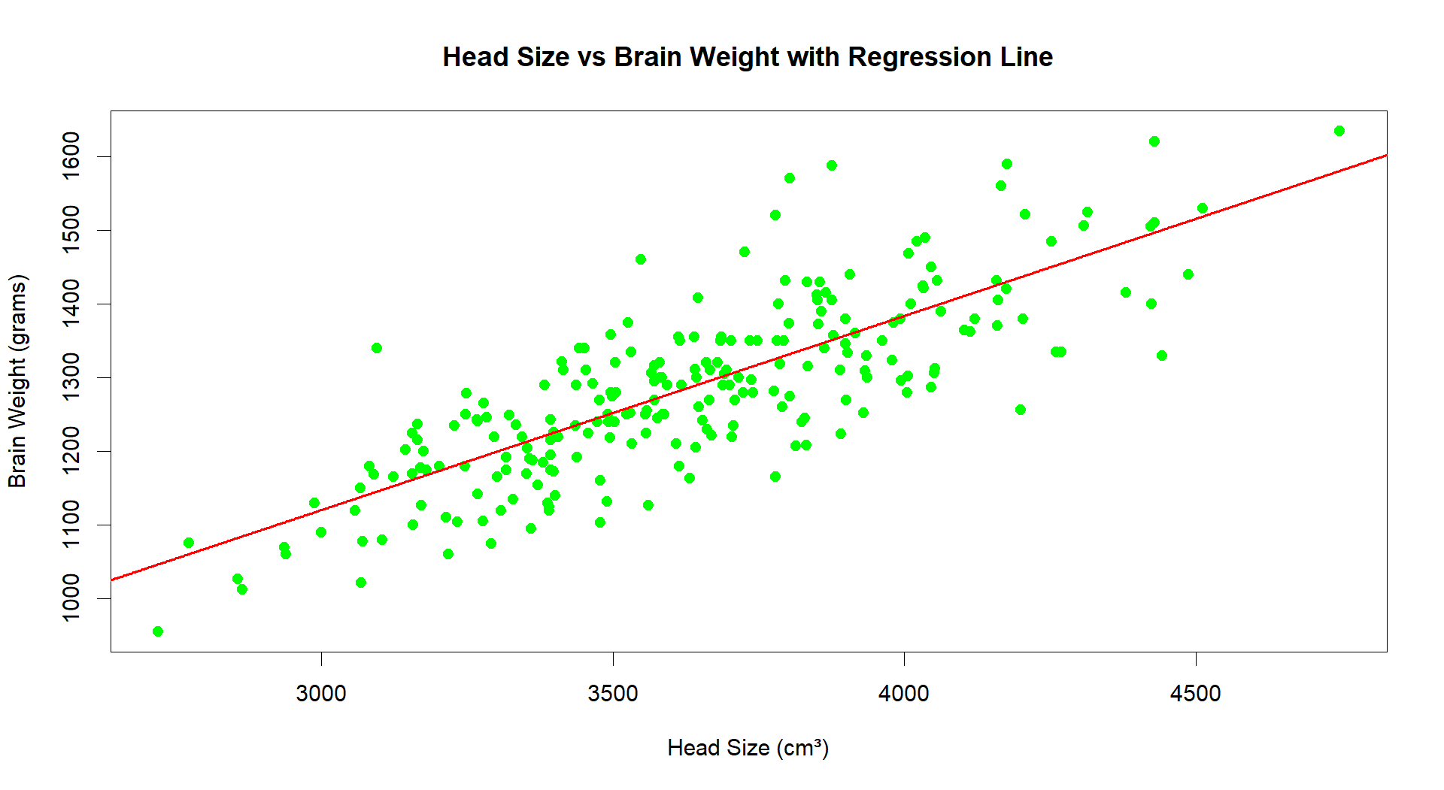

**Result:**

The Linear Regression is Successfully Implemented.



**Aim:**

Implement a Kmeans Clustering on the Given Dataset.

**Procedure:**

**Procedure for Performing and Evaluating K-means Clustering in R**

**1. Load Required Libraries**

* Load the necessary libraries:
  + ggplot2 for plotting.
  + cluster for silhouette analysis.
  + factoextra for easy visualization of clustering.

**Code:**

library(ggplot2)

library(cluster)

library(factoextra)

**2. Load the Dataset**

* Load the Iris dataset.
* Remove the Species column to focus only on the numeric features for clustering.

**Code:**

data(iris)

iris_data <- iris[, -5]

head(iris_data)

**3. Determine the Optimal Number of Clusters Using Elbow Method**

* Use the Within-Cluster Sum of Squares (WSS) method to decide how many clusters are appropriate.

**Code:**

fviz_nbclust(iris_data, kmeans, method = "wss") +

ggtitle("Elbow Method for Optimal K")

**4. Apply K-means Clustering with 3 Clusters**

* Set a random seed for reproducibility.
* Apply K-means clustering specifying 3 clusters (since Iris has 3 species).

**Code:**

set.seed(123)

kmeans_model <- kmeans(iris_data, centers = 3, nstart = 25)

**5. Print Cluster Centers and Cluster Assignments**

* View the center points of the clusters and how the data points were assigned.

**Code:**

print(kmeans_model$centers)

print(kmeans_model$cluster)

**6. Visualize the Clusters**

* Visualize the clustering result using a scatter plot with convex hulls around clusters.

**Code:**

fviz_cluster(kmeans_model, data = iris_data, geom = "point", ellipse.type = "convex") +

ggtitle("K-means Clustering on Iris Dataset")

**7. Evaluate the Clustering (Silhouette Analysis)**

* Perform silhouette analysis to assess the quality of the clustering.

**Code:**

silhouette_score <- silhouette(kmeans_model$cluster, dist(iris_data))

fviz_silhouette(silhouette_score)

**Output:**

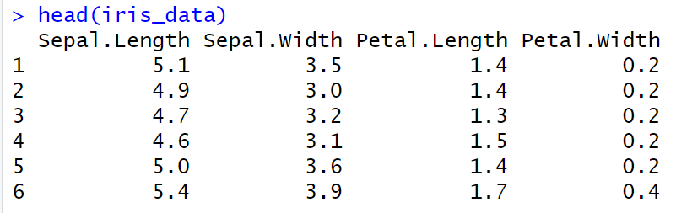

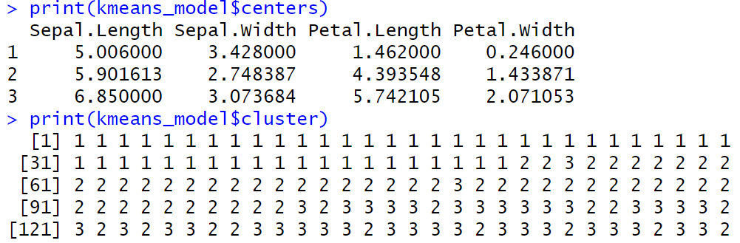

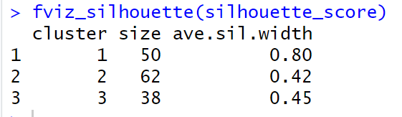

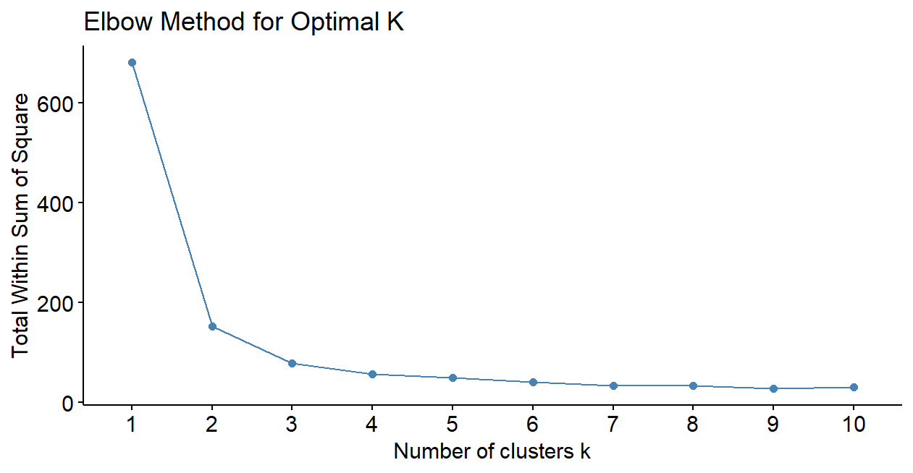

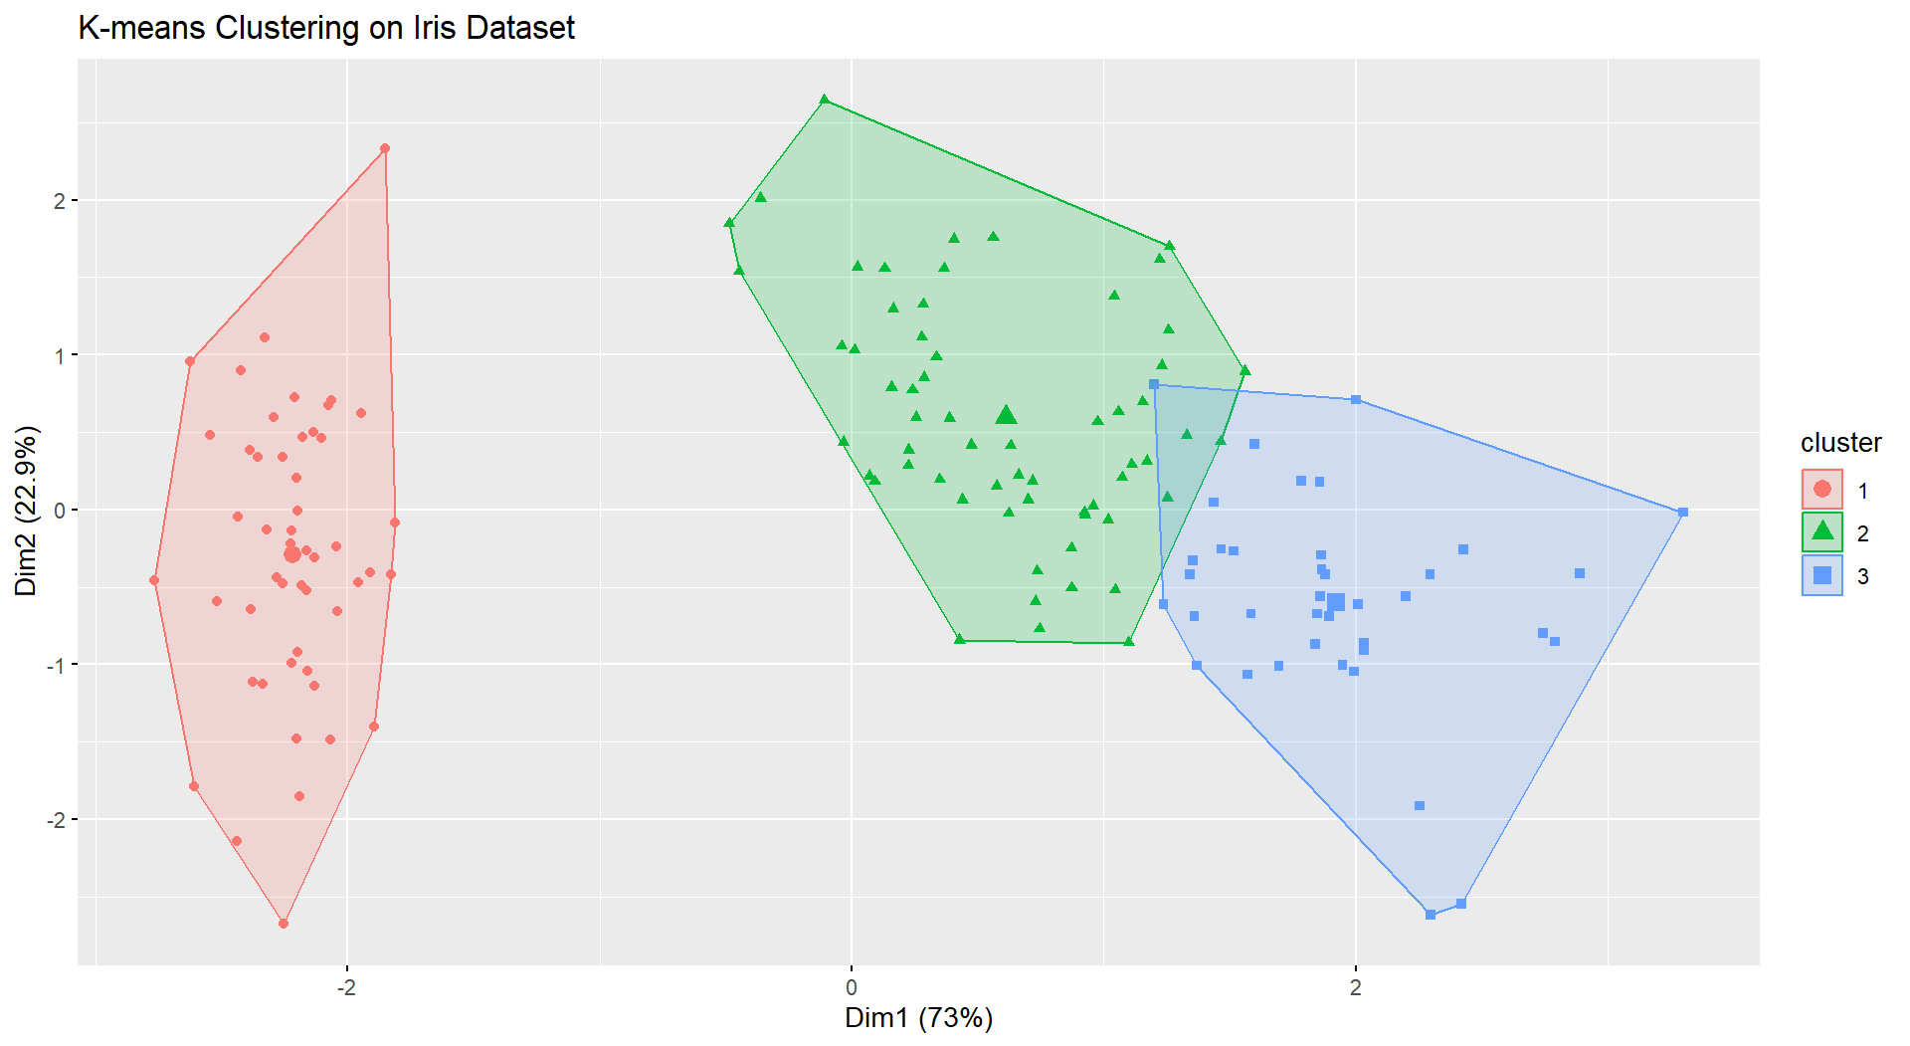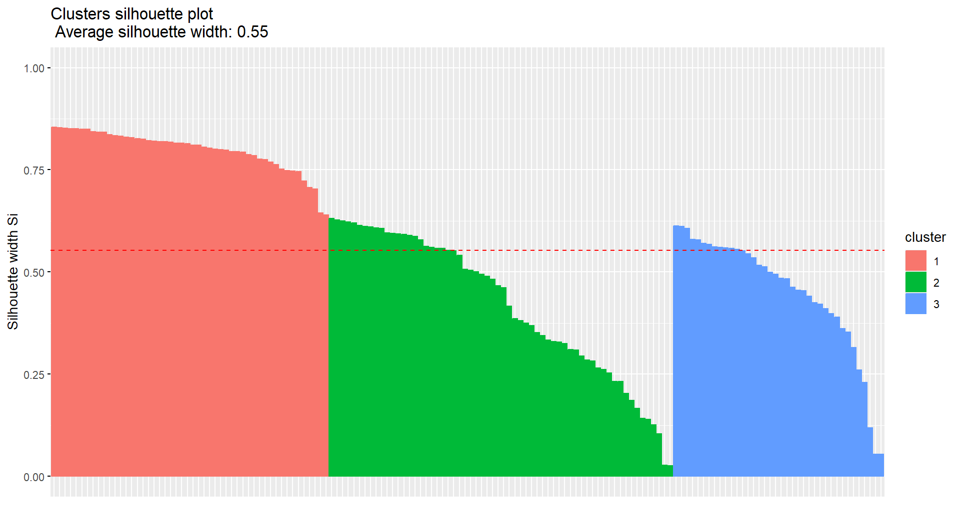

**Result:**

The Kmeans is Successfully Implemented.